Lesson Template

INFORMATION ABOUT THE RESEARCH TEAM
LESSON TITLE: Introducing planetary boundaries to chemistry curriculum
US DIVCHED MEMBER’S NAME: Alexey Leontyev
AFFILIIATION/ACADEMIC INSTITUTION: Adams State University
ADDRESS: 208 Edgemont Blvd.
EMAIL: alexleontyev@adams.edu
PHONE #: 419 308 9472
COLLABORATING PARTNER’S NAME: Natalia P. Tarasova
AFFILITATION /ACADEMIC INSTITUTION: Mendeleyev University of Chemical Technology of Russia
ADDRESS: Miusskaya pl., 9, Moskva, Russia, 125047
COUNTRY OF RESIDENCE: Russian Federation
EMAIL: tarasnp@muctr.ru
PHONE #: + 1 (499) 978-87-33
ADDITIONAL TEAM MEMBERS (PLEASE LIST):
N/A
DESCRIBE YOUR RESEARCH TEAM IN 2-3 SENTENCES:
Dr. Alex Leontyev is a recent Ph.D. graduate in chemistry education and now he is a professor of chemistry at Adams State University, where he promotes active learning and effective assessment in his classrooms and principles of green chemistry in his laboratories. Professor Natalia P. Tarasova is the Director of the Institute of Chemistry and Problems of Sustainable Development and the Chairholder of the UNESCO Chair in Green Chemistry for Sustainable Development at the D. Mendeleyev University of Chemical Technology of Russia, in Moscow, Russia. Dr. Leontyev and Professor Tarasova value green chemistry and sustainability and believe that both should be an essential part of chemistry curriculum at any level.

LESSON OVERVIEW
In this lesson, we attempted to introduce the idea of planetary boundaries to students in introductory chemistry classes. Planetary boundaries, a concept recently introduced by Johan Rockström and colleagues define the safe operating space for humanity with respect to the Earth system and are associated with the planet’s systems and processes. The nine processes are climate change, biodiversity loss, nitrogen and phosphorus loads, stratospheric ozone depletion, ocean acidification, change in land use, chemical pollution and atmospheric aerosol loading. Thresholds for these processes were identified that should not be transgressed if we want to maintain the stability of the Holocene state in which human civilizations were developed.
Chemistry concepts are directly linked to each of processes associated with planetary boundaries. For example, planetary boundaries of climate change and stratospheric ozone depletion are related to the concept of concentration and different ways to quantify it. The planetary boundary of the nitrogen and the phosphorus cycle is based on the concept of chemical change. The planetary boundary of ocean acidification is based on the concept of solubility and chemical equilibrium.
The lesson integrates strategies that facilitate conceptual change and cooperative learning. Students construct concept maps for several planetary boundaries described in the Rockström’s paper using concept mapping software and discuss this concept maps with their peers. At the end of the lesson, an instructor constructs concept maps that integrates all of the students’ work.
We believe that being aware of planetary boundaries and danger of crossing thresholds is an important part of the education process and promotes responsible stewardship of the Earth. We also believe that students learn more and at a deeper level when they are given an opportunity to construct knowledge themselves and integrate it into their prior knowledge.

LESSON PLAN

INTRODUCTION/PURPOSE

Recently, human activities pushed the Earth system outside the stable environmental state with consequences that can be catastrophic for large parts of the world. A concept of planetary boundaries was introduced by Rockström et al. (2009), which defines nine planetary systems and the status of human disturbance within them. Thresholds have been identified that should not be transgressed if we want to maintain the stability of the Holocene state in which human civilizations have developed. If crossed, these thresholds can generate unacceptable environmental change. The nine processes, for which such thresholds were defined, are climate change, biodiversity loss, nitrogen and phosphorus load, stratospheric ozone depletion, ocean acidification, change in land use, chemical pollution and atmospheric aerosol loading. The boundaries in three of the systems (rate of biodiversity loss, climate change and human interference with the nitrogen cycle) have already been exceeded and are to bring consequences. In this lesson, we have attempted to introduce these boundaries to chemistry curriculum through an active learning approach. We chose concept mapping technique to facilitate learning about planetary boundaries and help students see interconnections between chemistry concepts and different planetary boundaries, as well as interaction of planetary boundaries. Concept mapping is a method of organizing and displaying the concepts and the relationships of concepts that constitute learning materials. Concept mapping is a learning strategy that attempts to enable learners to acquire new concepts in a meaningful way (Novak & Gowin, 1984).
LEARNING OBJECTIVES
Lesson goal: Introduce the concept of planetary boundaries and their thresholds to students in introductory chemistry classes
Learning outcomes:
- Students will identify planetary boundaries and their thresholds
- Students will apply chemistry principles to planetary boundaries
- Students will recognize interconnections and interference of planetary boundaries
MATERIALS/SUPPLIES
Access to laptops or tablets with installed software for drawing concept maps (there are many options, such as CmapTools, Coggle, LucidChart or any other that allows online collaboration.
ACTIVITY
1) The lesson will begin with a brief explanation by an instructor of planetary boundaries.
2) An instructor will introduce an idea of concept maps and illustrate with one example from previously covered content. An instructor will emphasize why concept maps are important for learning. Handout “Guidelines for Constructing Concept Maps” can be distributed at this time.
3) An instructor will explain the task and assign planetary boundaries to groups.
4) Students will read the paper “A safe operating space for humanity” by Rockström et al. (2009) and excerpts from Steffen et al. (2015) papers and construct a concept map for 2-3 planetary boundaries in each group using concept seeds from the paper.
5) Concept maps will be constructed using web-based tools or software and shared with other students.
6) Groups will exchange their concept maps, discuss them, compare and contrast them with their own maps
7) At the end of the lesson, an instructor will synthesize all maps on a whiteboard, emphasizing the interconnection of boundaries and their impact on each other

QUESTIONS
Questions 1-3 address the lower levels of Bloom’s taxonomy, whereas questions 3-7 relate to the higher levels of Bloom’s taxonomy.
1) What are the planetary boundaries?
2) List all planetary boundaries.
3) Which planetary boundaries are crossed?
4) What are the factors that affect the trend for biodiversity loss (ocean acidification, stratospheric ozone depletion, or any other planetary boundaries)?
5) Given that the current trend continues, when do you think the boundaries for (ocean acidification, stratospheric ozone depletion, or any other planetary boundaries) will be crossed? Do you think the current trend is linear, exponential, or sigmoidal?
6) There are two boundaries for which the threshold was not determined. Why do you think it is hard to propose a single number for these boundaries?
7) In the updated version of planetary boundaries framework (Steffen et al., 2015) the planetary boundary of chemistry pollutions is replaced by the planetary boundary of novel entities. Compare and contrast these proposed planetary boundaries and point out their discrepancies.
CLOSURE
- An instructor will combine students’ concept maps on a whiteboard.
- An instructor will pose a questions “What else is needed to maintain the current state of sustainability?” and allow students to voice their opinions.
- An instructor will introduce the idea of social boundaries (such as gender and social equality, access to healthcare, education, and fresh water and so on) and form the doughnut of social and planetary boundaries.
ASSESSMENT/EVALUATION
- Students’ concept maps can be assessed to assign a numerical value to their work. A method of assessing concept maps proposed by Novak and Gowin (1984) is based on the components and structure of the map. This system awards points for: valid propositions (1 point each), levels of hierarchy (5 points for each level), number of branchings (1 point for each branch), crosslinks (10 points for each valid crosslink), and specific examples (1 point for each example).
- Selected questions from Atmosphere-Related Environmental Problems Diagnostic Test by Arslan, Cigdemoglu, and Moseley (2012) can be used to assess if students possess certain misconceptions.
- Students will also receive a verbal/written feedback on the quality of their concept map and relevancy of the proposed connections.
- Indexes of Knowledge of, Favourable Attitudes and Behaviours toward Sustainable Development (Michalos et al., 2009) can provide insights into affective and behavioral outcomes of this lesson.
1. Planetary boundaries (Figure 1 and Table from Rockström, 2009)
2. Guidelines for Constructing Concept Maps (Instructions for students how to make a concept map if they are not familiar with this technique)
3. Printouts of Rockström (2009) and Steffen (2015) papers.
4. The doughnut of social and planetary boundaries (Figure from www.kateraworth.com/doughnut/)

References

Arslan, H. O., Cigdemoglu, C., & Moseley, C. (2012). A three-tier diagnostic test to assess pre-service teachers’ misconceptions about global warming, greenhouse effect, ozone layer depletion, and acid rain. International Journal of Science Education, 34(11), 1667-1686.

Michalos, A. C., Creech, H., McDonald, C., & Kahlke, P. M. H. (2009). Measuring Knowledge, Attitudes and Behaviours towards Sustainable Development: Two Exploratory Studies. Institute for Social Research.

Novak, J. D., & Gowin, D. B. (1984). Learning how to learn. Cambridge University Press.

Rockström, J., Steffen, W., Noone, K., Persson, Å., Chapin, F. S., Lambin, E. F., ... & Nykvist, B. (2009). A safe operating space for humanity. Nature, 461(7263), 472-475.

Steffen, W., Richardson, K., Rockström, J., Cornell, S. E., Fetzer, I., Bennett, E. M., ... & Folke, C. (2015). Planetary boundaries: Guiding human development on a changing planet. Science, 347(6223), 1259855.

Instructor’s Guide
MATERIALS
The following handouts will help to facilitate this lesson:
1. Planetary boundaries (Figure 1 and Table from Rockström, 2009)
2. A printout of Rockström (2009) paper and Steffen (2015) paper.
3. The doughnut of social and planetary boundaries (Figure from www.kateraworth.com/doughnut/)
4. Guidelines for constructing concept maps
ADVANCE PREPARATION
An instructor needs to be familiar with the idea of planetary boundaries and concept mapping technique.
SAFETY CONSIDERATIONS
None.

Guidelines for Constructing Concept Maps

1. Select a section of text for mapping. Identify the main or the central concept.

2. List the important concepts on a separate piece of paper. Reminder – a concept is a word which stands for an object.

3. Rewrite the list. Arrange the words in order from the most general to the most specific.

4. Group the concepts into cluster. Put the concepts that are related together. Order the separate group from general to specific.

5. Start mapping. Place the most general concept at the top of the map. Link it to one or more less inclusive concepts. Label all lines with linking words. Work with one pair of concepts at a time. Read your map from top to bottom.

6. Try to form branches, as on a tree. Try to have more than one concepts to each one above it on the map.

7. Go back and see if you can create cross-links between concepts already on your map. Label all linking lines.

8. Go back and change your map or make it clearer by drawing a new one if you feel it is necessary.

Concepts, which you may wish to include for stratospheric ozone depletion concept map, are:

Ozone, Dobson Units, ultraviolet radiation, molecular oxygen (O₂), atomic oxygen (O), CFC, the Antarctic ozone "hole", methane, polar vortex, climate change.

You may use some or all of the listed concept words. You may also add concepts of your choice to make your map meaningful to you.

Taken with modifications from Leary, R. F. (1993). Effect of concept maps on concept learning and problem-solving achievement in high school chemistry. Arizona State University.

Planetary boundaries

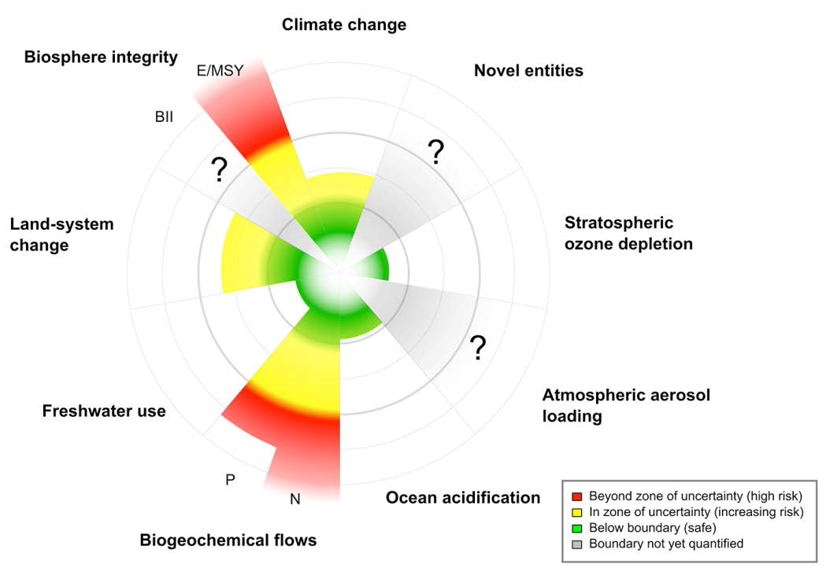

The current status of the control variables for seven of the nine planetary boundaries. Green zone is the safe operating space (below the boundary), yellow represents the zone of uncertainty (increasing risk), and red is the high-risk zone. The planetary boundary itself lies at the inner heavy circle. The control variables have been normalized for the zone of uncertainty (between the two heavy circles); the center of the figure therefore does not represent values of 0 for the control variables. The control variable shown for climate change is atmospheric CO₂ concentration. Processes for which global-level boundaries cannot yet be quantified are represented by gray wedges; these are atmospheric aerosol loading, novel entities and the functional role of biosphere integrity.

Taken from Rockström, J., Steffen, W., Noone, K., Persson, Å., Chapin, F. S., Lambin, E. F., ... & Nykvist, B. (2009). A safe operating space for humanity. Nature, 461(7263), 472-475.

The doughnut of social and planetary boundaries

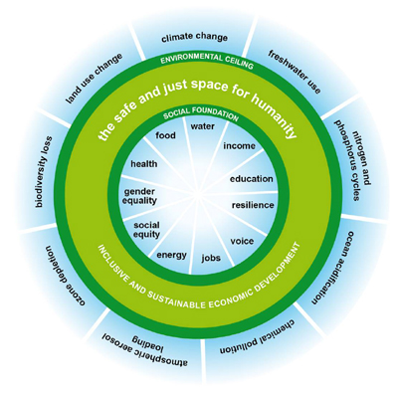

Taken from http://www.kateraworth.com/doughnut/

